**Why Bishop’s Castle needs a Community Hub and Project officer**

**Mission Statement:**

To create ‘a facility that holistically supports the needs of vulnerable and other groups; promoting good mental health and well-being of individuals over their life-course; helping to form a connected, optimistic thriving community, full of opportunity and prosperity.’

We want to connect people who need help, advice and inspiration, with people and projects that can provide:

* **Young People** - providing activities, skilling up to raise aspirations
* **Mental Health** - emphasis on young people’s mental health
* **Older People** - tackling social isolation and loneliness - e.g. befriending service
* **Food Poverty** - providing access to food for those suffering food poverty

Demand for our services has dramatically increased as COVID -19 has left people isolated, unwaged and….

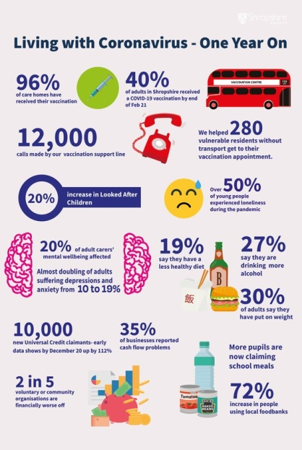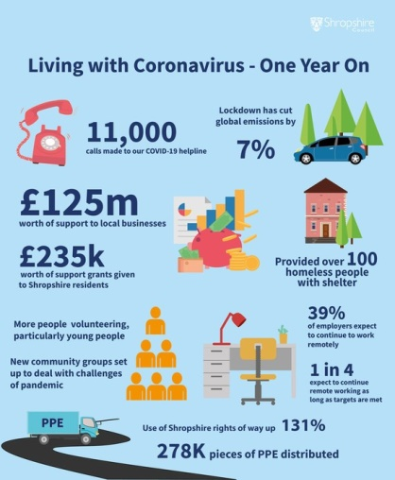

* 9 suicides among young people in the 5 years preceding 2020
* 37% increase in Free School Meals in Shropshire 2019-20
* Little provision for regular and organised leisure activities for children and young people
* Post-16 education travel costs are costly - preventing many young people accessing further education
* Limited job opportunities in the Town
* The Food Bank was only established April 2020 – now has more than 85 clients per week (Started in response to the pandemic, the food bank now provides food and other vital supplies (nappies, sanitary products etc.) to an average of 80-100 customers at each of its twice weekly sessions.)
* The Food Bank needs a permanent home with space for fridges, a freezer, bulk food storage and the development of other food resilience activities (e.g. cookery skills; preparing healthy meals etc.).
* High proportion of older people in Bishop’s Castle - 23.9% aged 65 and over, compared with 16.3% nationally
* Social isolation - significant number of people aged 50+ living alone in Bishop’s Castle compared to national average
* Limited public transport services makes access to advice and advocacy services such as Citizens Advice difficult
* We want to develop a programme of activities for young people in the town. And involve them much more in decision-making. For this we will need a Youth Forum managed by a youth worker
* CLT are providing two units of accommodation one of which has the potential to be a “safe house” in flat for local young people
* A resource hub facilitating access to advocacy, legal and debt advice